D+ Documentation
For beginner Programmer

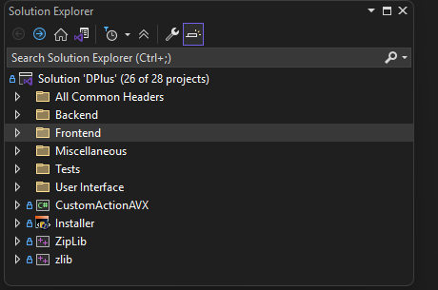
Solution Explorer Overview:
Solution 'DPlus'
This is the top-level container for your entire application. It can contain multiple projects, which is written in C++.
1. All Common Headers
This folder typically contains header files (.h) that are shared across multiple projects. These files define common data structures, functions, or constants that can be reused, helping to avoid code duplication.

2. Backend
Purpose:
Core computational logic, scientific algorithms, and data processing.
Main Classes:
Amplitude, JobManager, Job, LocalBackend, BackendWrapper, PythonBackendWrapper, CommandLineBackendWrapper, ModelFitting.

3. Frontend
Purpose:
Handles user interaction, orchestrates UI logic, and mediates between UI and backend.
Main Classes:
LocalFrontend, BackendCaller, BackendCalls, Python Backend folder.

4. User Interface
Purpose:
Reusable UI components, controls, and dialogs shared across the application.
Main Classes:
MainWindow, ManagePythonPreCaller, Dockable Panes folder.

For better understanding, we recommend you follow the call stack of our example of a generic use of DPlus, with both frontend and backend focus. @see in each UI, Backend, Frontend overview.

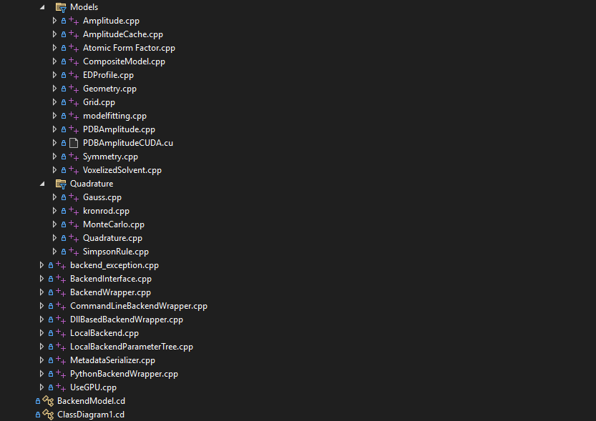
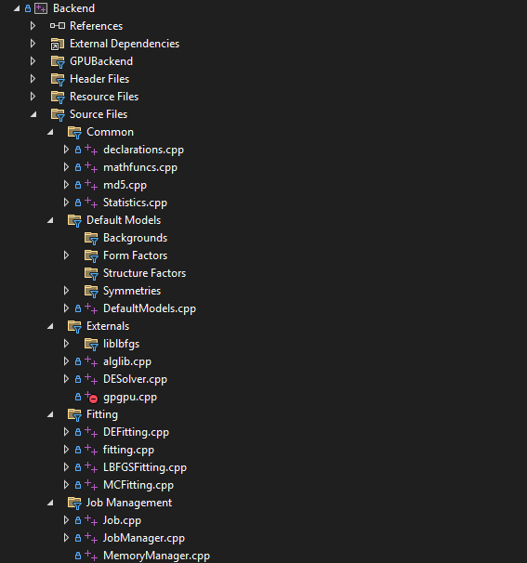
Backend classes
Overview: The Backend
The Backend is the computational engine of DPlus. It handles all the heavy calculations, data management, and fitting algorithms. The backend is organized into folders by functionality (Common, Models, Fitting, Job Management, etc.), and the files you asked about are central to how jobs (calculations) and fitting (optimization) are managed and executed.
---
Key Files Explained
1. Job.cpp
- Location: Job Management/Job.cpp
- Purpose: Represents a single calculation or fitting task (a "job").
- What it does:
  - Defines the Job class, which holds all information about a calculation: input parameters, status, results, etc.
  - Manages the lifecycle of a job (creation, execution, completion, error handling).
  - Provides methods to start, stop, and query the status of a job.
- Context: Every calculation or fit is wrapped in a Job object, making it easy to manage multiple tasks.
2. JobManager.cpp
- Location: Job Management/JobManager.cpp
- Purpose: Manages all jobs in the system.
- What it does:
  - Defines the JobManager class, which keeps track of all active, queued, and completed jobs.
  - Handles job scheduling, prioritization, and resource management.
  - Provides an interface for the frontend or other modules to submit new jobs, check progress, or retrieve results.
- Context: Ensures the backend can handle multiple jobs efficiently and safely.
3. LocalBackend.cpp
- Location: Root of backend source files.
- Purpose: Implements the main backend logic for running locally (on the user's machine).
- What it does:
  - Coordinates between the frontend and the backend computation modules.
  - Receives requests (like "run this job" or "fit this model") and delegates them to the appropriate classes (like JobManager or fitting routines).
  - Handles local resources, file I/O, and error reporting.
- Context: This is the main entry point for backend operations when running on a local computer.

4. BackendWrapper.cpp
- Location: Root of backend source files.
- Purpose: Provides a C/C++ interface for the backend, making it accessible from other languages or modules (like C# or Python).
- What it does:
  - Exposes backend functions as a set of C-style APIs (using extern "C"), so they can be called from managed code or other DLLs.
  - Handles data marshaling between C++ and other languages.
- Context: Used by the frontend or external tools to interact with the backend without needing to know C++ internals.
5. PythonBackendWrapper.cpp
- Location: Root of backend source files.
- Purpose: Specialized wrapper for Python integration.
- What it does:
  - Exposes backend functionality to Python scripts or modules.
  - Handles conversion between C++ data structures and Python objects.
  - Enables advanced scripting, automation, or use of Python-based algorithms within the DPlus backend.
- Context: Used when the application needs to run Python code or when Python scripts need to access backend features.
How They Work Together
- Frontend/User requests a calculation or fit, and sends it to PythonBackendWrapper.cpp -> BackendWrapper.cpp ->
- LocalBackend.cpp receives the request and creates a Job (Job.cpp).
- The JobManager (JobManager.cpp) manages the job, schedules it, and tracks its progress.
- If the job is a fit, fitting.cpp runs the optimization algorithm.
- Results are returned to the frontend all the way up – mainly via JobManager::completeJob

Example: Clicking “Generate” for add Scripted Symmetry-> Left and Helix Lua File -> sphere
Backend Focus:

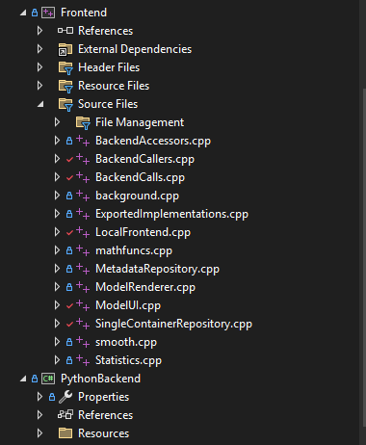
2. BackendCalls.cpp
- Purpose: Implements the specific backend operations that can be requested from the frontend.
- What it does:
  - Contains the actual functions that are called by BackendCallers.cpp to perform backend operations.
  - Manages the details of data formatting, parameter passing, and result handling.
  - May include logic for both local and remote backend calls.
- Context: This file is where the "work" of calling the backend is defined. If you want to add a new type of calculation or fitting operation, you would likely add it here.

3. LocalFrontend.cpp
- Purpose: Implements the frontend logic for running DPlus locally (on the user's machine).
- What it does:
  - Coordinates between the UI and the backend when everything is running on the same computer.
  - Handles local data management, file I/O, and error reporting specific to the frontend.
  - May provide additional utilities for managing models, results, or user preferences.
- Context: This is the main entry point for frontend operations when not using a remote server or cloud backend.
Overview: The Frontend
The Frontend is the user-facing part of DPlus. It acts as the bridge between the user interface (UI) and the backend computational engine. The frontend is responsible for:
- Handling user actions (like clicking buttons or changing settings)
- Preparing and sending requests to the backend for calculations or fitting
- Receiving results from the backend and updating the UI (such as displaying graphs or results)
- Managing data and models on the client side
The frontend is organized into source files by functionality, making it easier to understand and extend.
Key Files Explained
1. BackendCallers.cpp
- Purpose: Provides the main interface for the frontend to communicate with the backend.
- What it does:
  - Defines classes and functions that prepare and send requests to the backend (for example, to start a calculation or fitting job).
  - Handles the responses from the backend, including results and error messages.
  - Abstracts away the details of how the backend is called, so the rest of the frontend can use simple function calls.
- Context: Whenever the user triggers an action that requires backend computation (like generating a model or running a fit), the frontend uses the code in BackendCallers.cpp to make that happen.

4. Python Backend (PythonBackend project)
- Purpose: Enables integration with Python for advanced scripting, automation, or using Python-based algorithms.
- What it does:
  - Provides a way for the frontend to call Python scripts or modules as part of the calculation pipeline.
  - Handles data conversion between C++/C# and Python.
  - Useful for users who want to extend DPlus with custom Python code or leverage Python libraries.
- Context: If a user writes a Python script to generate a model or process results, the frontend can use the Python backend to run that script and integrate the results.

How They Work Together
- User Action: The user interacts with the UI (e.g., clicks "Generate" or "Fit").
- Frontend Request: The frontend (via BackendCallers.cpp) prepares a request and sends it to the backend, possibly using BackendCalls.cpp for the specific operation.
- Backend Processing: The backend performs the requested calculation or fitting.
- Result Handling: The frontend receives the results, processes them (possibly using LocalFrontend.cpp), and updates the UI.
- Python Integration: If the operation involves Python code, the frontend communicates with the Python backend to execute the script and retrieve results.

Example Flow
- Clicking "Generate":
  - The UI triggers a function in BackendCallers.cpp.
  - This function calls the appropriate method in BackendCalls.cpp to start the calculation.
  - If running locally, LocalFrontend.cpp manages the data and coordinates with the backend.
  - If a Python script is involved, the frontend uses the Python backend to execute it.
  - Results are returned to the frontend, which updates the UI (e.g., displays a graph).

Example: Clicking “Generate” for add Scripted Symmetry-> Left and Helix Lua File -> sphere
See after User Interface section.
Overview: The User Interface (UI) in DPlus
The User Interface (UI) is the part of DPlus that users see and interact with. It provides all the windows, buttons, menus, and controls needed to build models, run calculations, fit data, and visualize results. The UI is designed to be flexible and powerful, supporting both standard workflows and advanced scripting.

Key Responsibilities
- Display and manage models, parameters, and results
- Handle user actions (like clicking "Generate", loading files, or editing parameters)
- Coordinate with the frontend to send calculation requests and receive results
- Integrate scripting (Lua and Python) for advanced customization and automation
- Provide feedback (progress bars, error messages, status updates)

Main Components
1. MainWindow
- Role: The central window and controller for the entire application.
- What it does:
  - Initializes and manages all other UI panes (2D/3D graphs, parameter editors, symmetry editors, etc.).
  - Handles application startup, shutdown, and layout saving/loading.
  - Manages communication with the frontend and backend (local or remote).
  - Provides workflows for model generation, fitting, parameter editing, and exporting results.
  - Integrates Lua scripting for advanced model and parameter manipulation.
  - Handles error reporting, progress updates, and job status polling.
- Context: When you launch DPlus, this is the main window you interact with. It orchestrates all UI and backend operations.
2. ManagePythonPreCaller
- Role: Bridges the UI and Python scripting.
- What it does:
  - Allows users to run Python scripts as part of their modeling or fitting process.
  - Manages the setup, execution, and result retrieval for Python-based operations.
  - Ensures that Python scripts can be used seamlessly within the DPlus workflow.
- Context: If you want to automate tasks or use custom Python code, this component handles the details and ensures results are shown in the UI.

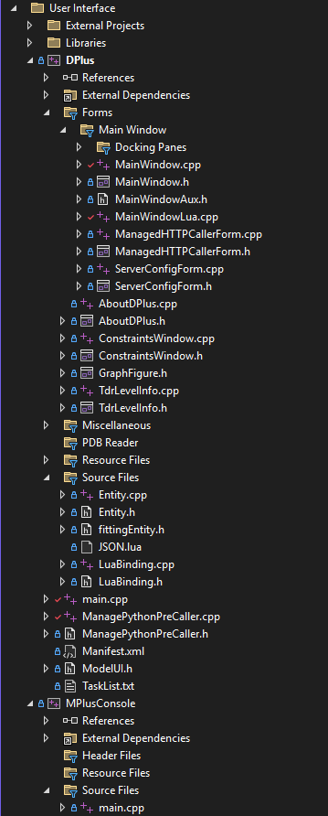

3. Dockable Panes
- Examples: GraphPane2D, GraphPane3D, SymmetryEditor, PreferencesPane, ParameterEditor, ScriptPane, CommandWindow, etc.
- Role: Specialized windows for editing parameters, viewing results, scripting, and more.
- What they do:
  - Each pane provides a focused set of controls (e.g., 2D/3D visualization, parameter editing, scripting).
  - Panes can be shown, hidden, or rearranged to suit the user's workflow.
  - All panes are managed by the MainWindow and can be saved/restored as part of the layout.
How the UI Interacts with the Backend
- User Action: The user interacts with the UI (e.g., clicks "Generate" or "Fit").
- UI Coordination: MainWindow processes the action and, if needed, uses ManagePythonPreCaller for Python scripting.
- Frontend Request: The UI sends a request to the frontend, which communicates with the backend.
- Backend Processing: The backend performs the requested calculation or fitting.
- Result Handling: The frontend receives the results and passes them back to the UI.
- UI Update: MainWindow and the relevant panes update the display with new graphs, models, or results.
---
Example Workflow
- Clicking "Generate":
  - The user clicks "Generate" in the main window.
  - MainWindow gathers all parameters and model information.
  - If Python scripting is involved, ManagePythonPreCaller is used to run the script.
  - The UI sends a calculation request to the frontend.
  - The backend computes the result and sends it back.
  - The UI updates the graphs and parameter editors with the new results.

Example: Clicking “Generate” for add Scripted Symmetry-> Left and Helix Lua File -> sphere
Frontend & UI Focus:

